
Maintenance Fitter
(Mechanical/Electrical/Instrumentation)
 | The Gold Standard  Job Role skills, knowledge and behaviours | Gold Standard Qualifications*  Awards, Certificates & Diplomas  & Training Standards
Technical Competence | The individual can…  - prepare the work area for maintenance of plant, systems or components.  - carry out planned maintenance activities efficiently.  - reinstate the work area after completing the maintenance of plant, system and components.  - conduct safe and effective hand over of plant and equipment to others and accept and confirm responsibility for the control of the plant and equipment within the work isolation boundary.  - identify obsolescence and end-of-life issues.  The individual understands...  - how to read and extract information from engineering drawings, specification diagrams and maintenance manuals.  - technical details relating to the individuals specialist discipline (mechanical, electrical, instrumentation). | Level 2 S/NVQ Engineering Maintenance  Technical Certificate in Engineering Maintenance
Compliance | - the reasons for and application of a variety of safety management systems (such as Permit to Work, Standard Maintenance Procedures and Pont of Work Risk Assessment)  - the implications and relevance of company policy, external legislation and regulation on working practices (including environmental control). | IOSH Working Safely



Maintenance Fitter
(Mechanical/Electrical/Instrumentation)

 | The Gold Standard  Job Role skills, knowledge and behaviours | Gold Standard Qualifications*  Awards, Certificates & Diplomas  & Training Standards
Business  Improvement | An individual may be required to...  - solve routine maintenance problems using efficiency improvement techniques.  - apply workplace organisation techniques.  - understand the practice associated with a variety of appropriate efficiency improvement techniques. | Level 2 NVQ in Business Improvement
Functional &  Behavioural | The individual has basic skills in…  - communications.  - numeracy.  - ICT.  - Team Working and Personal Development.  Additionally an individual may develop the ability to…  - take responsibility for completing tasks and procedures.  - work independently subject to overall direction or guidance.  - contribute towards the improvement of collaborative working.  - take responsibility for coaching others where appropriate.  - take responsibility for personal development. | Can be acquired through GCSE and Core/Functional skills programmes  Optional  Level 2 ILM Award In Personal Development

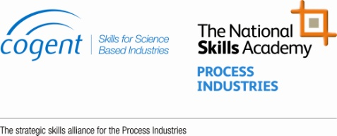
For more information on how to achieve the Gold Standard contact us on 0845 607 0140

